1. **What is the difference between an Application Server and a Web Server?**

|  |  |  |
| --- | --- | --- |
|  | **APPLICATION SERVER** | **WEB SERVER** |
| ***General*** | *Limited to handling HTTP request* | *Executes programs ,Routines, or scripts that support application construction* |
| ***Content*** | *Limited to sent static HTML content for display in web browser* | *Provides access to server-side logic* |
| ***Visual Display*** | *Adding content extensions are technically possible , but time-consuming, difficult to use and maintain* | *Includes web server with a complete integrated application server framework* |
| ***Scope*** | *May be used alone in certain limited circumstances* | *May be utilised as GUI engine for remote displays* |
| ***Limitation*** | *Content creation is time consuming and lack-luster for server-side application* | *Support any web application and modern UI* |

1. **Write down name of Application Servers and Web Servers.**

*Application Server Names:- TOMCAT,Enhydra,GlassFish,Jetty*

*Web Server Names:-Nginx , IIS , Apache,LightSpeed Web Server*

1. **What are java servlet?**

*A Java servlet is a Java software component that extends the capabilities of a server. Although servlets can respond to any types of requests, they most commonly implement web containers for hosting web applications on web servers and thus qualify as a server-side servlet web API.*

1. **Describe tomcat directory structure.**

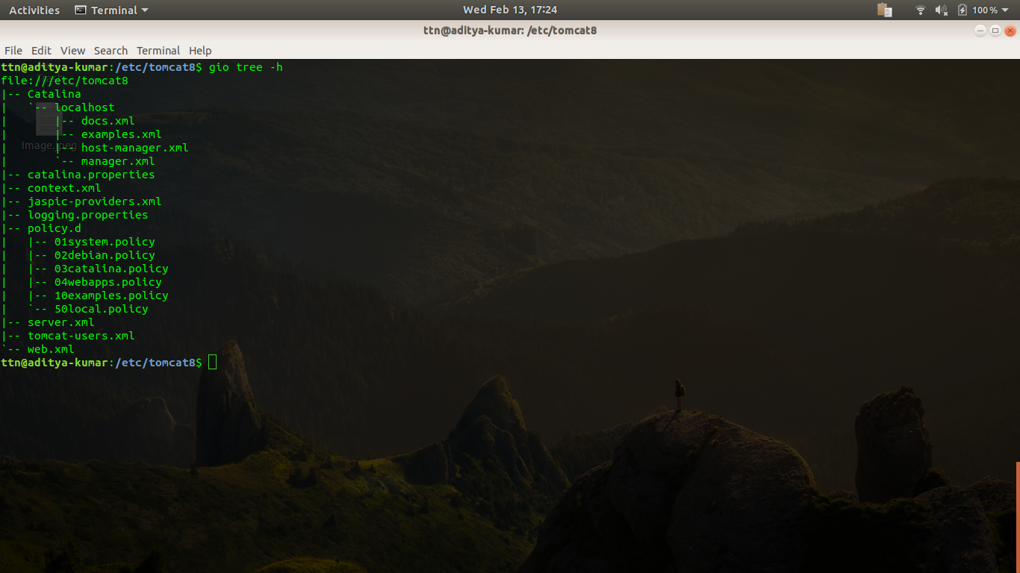

1. **How to change default port in tomcat?**

*In the above listed directory find ‘server.xml’*

*Find connector port and replace port number (8080:Default) to your decided port*

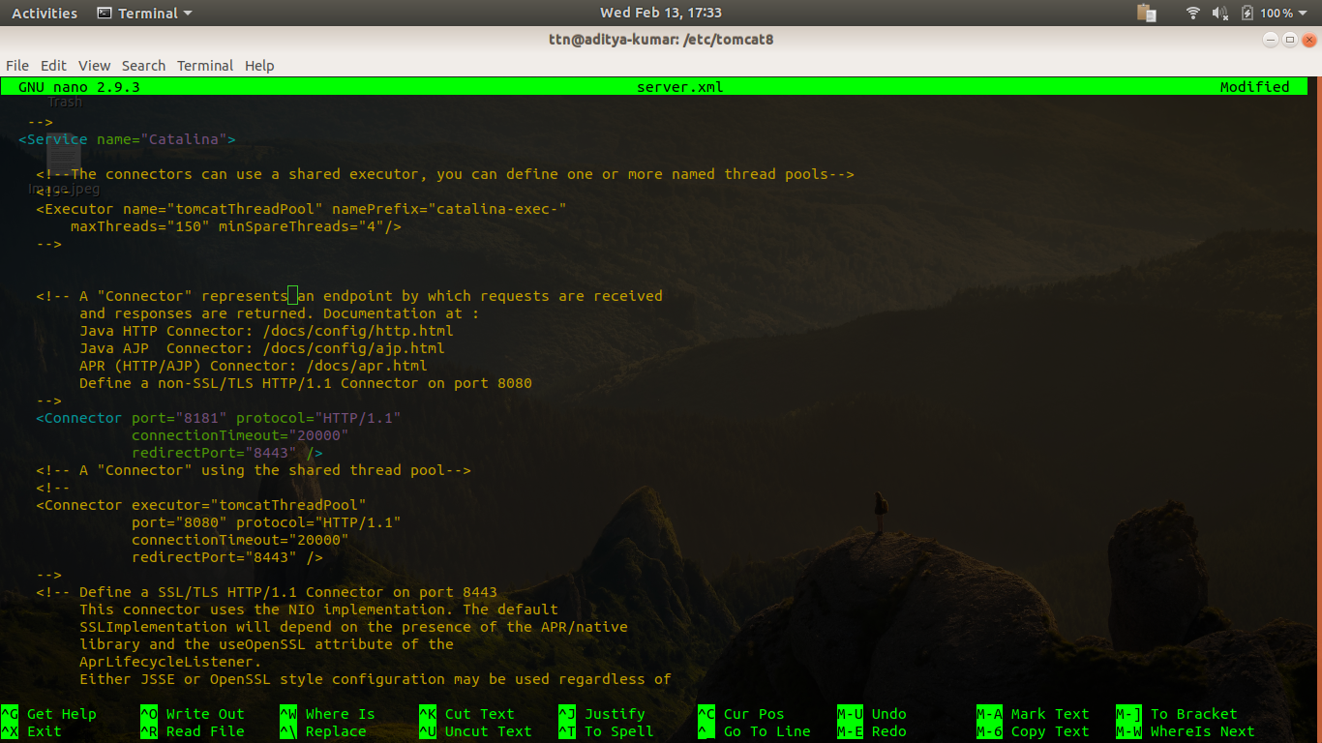

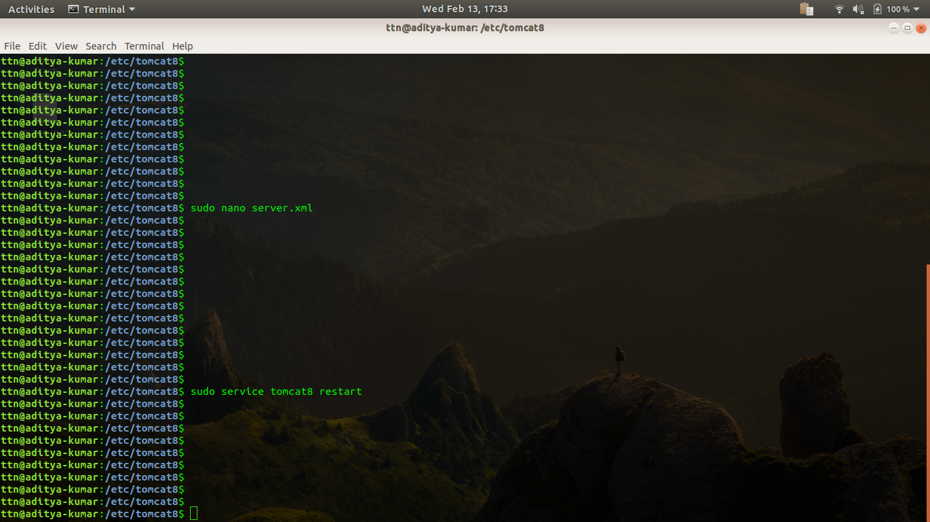

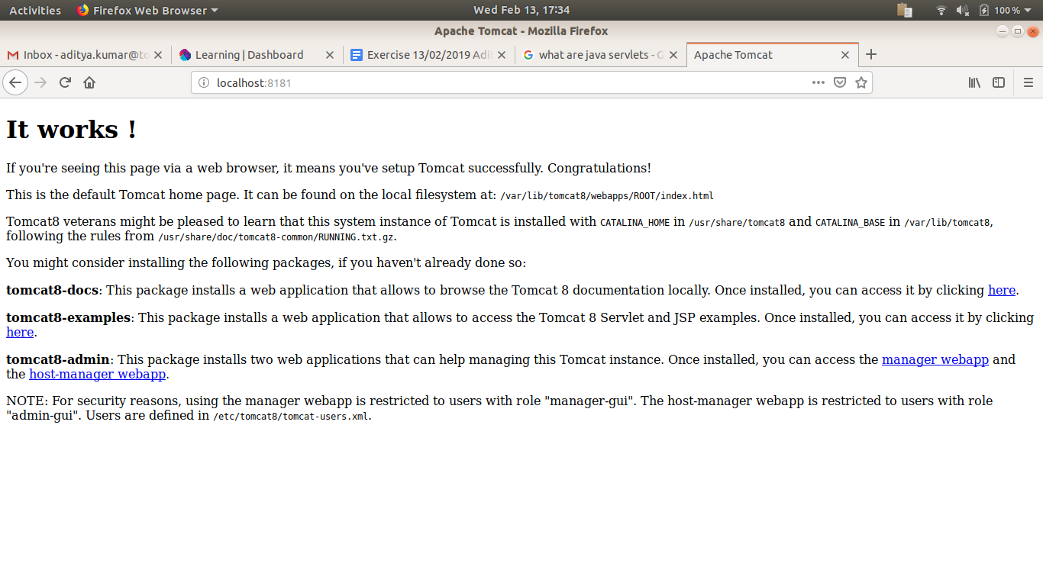

1. **Install tomcat and nginix and set proxy_pass in nginx to display tomcat.**

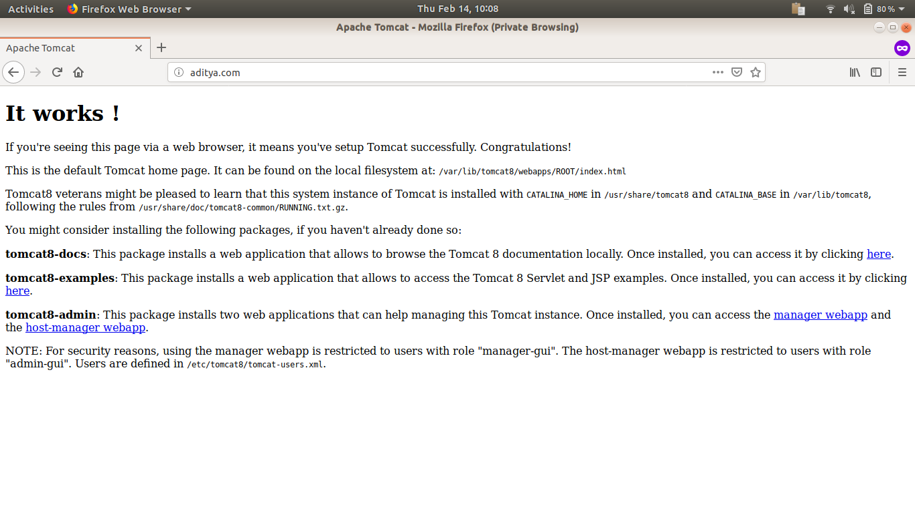

*Here in this question a conf file named aditya is being configured in /etc/nginx/sites-available*

*And a softlink of this file is being created in /etc/nginx/sites-enabled*

*After doing all the above mentioned steps whenever aditya.com is being hit ..it opens the page for tomcat localhost.*

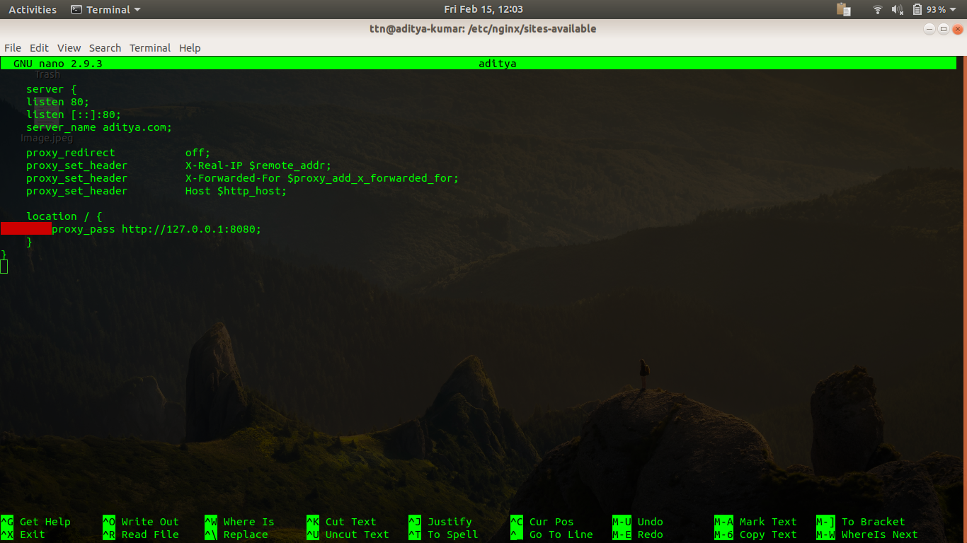

1. **Configure Tomcat as a Service**

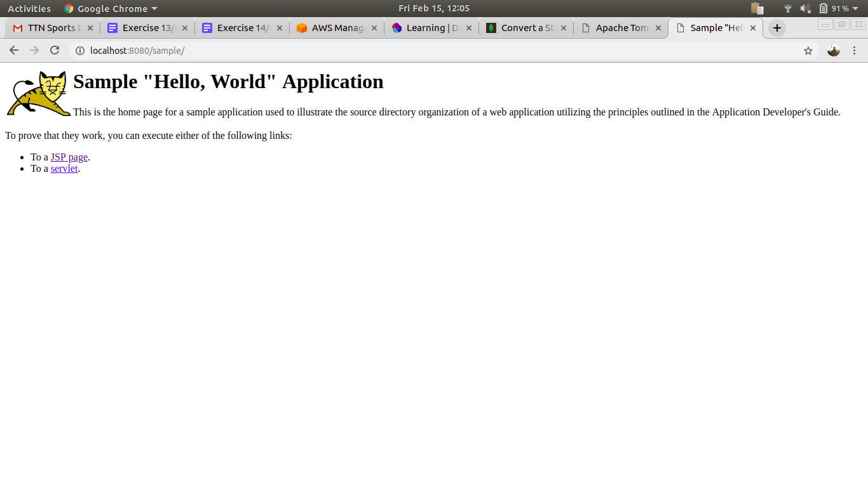

*Tomcat as a service can be easily seen when a sample site is being configured.*

1. **Use any web server in front of tomcat using AJP and HTTP connection**





